School of Computer Science Engineering & Information Science
A Report on
Mini-Project
Title : “Cafe Management System”
Course Title: Web Technologies
Course Code: CSE2258
Date of Submission: 22/11/2025

Submitted By:
- Harish VS - 20241IST0065
- Kanishka Suthar - 20241IST0066
- Mohammed Zubair - 20241IST0067
- Divya KS - 20241IST0068
- Fathima Nowshad - 20241IST0069

Index
- Abstract
- Introduction
- Software and Hardware Requirements
- Modules/Functionalities
- Results with Screenshots
- Conclusion

Abstract
This mini-project presents a simple and responsive Cafe Management System designed using HTML and CSS. It provides an online menu, about and contact pages, and a functional order form with client-side validation. The system demonstrates core principles of web design and frontend development and showcases how small-scale businesses can maintain an online presence efficiently.

Introduction
The Cafe Management System is developed as part of the Web Technologies course to demonstrate the implementation of basic web application features. The system includes menu display, order placement, and cafe information pages. It uses semantic HTML for structure, CSS for styling and user interaction.

Software and Hardware Requirements
Software Requirements:
- Notepad or any code editor (VS Code, Sublime Text, etc.)
- Web Browser (Google Chrome, Firefox, Edge)
- Optional: Local server for testing
Hardware Requirements:
- Standard desktop or laptop with minimum 2GB RAM
- Internet connection (optional for testing)

Modules / Functionalities
- Home Page
Landing page with navigation and introduction.
- Menu Page
Displays food and beverage items with images, descriptions, and prices.
- About Page
Provides information about the cafe’s background and mission.
- Contact Page
Shows address, contact number, and email of the cafe.
- Order Page
Allows users to place orders with JavaScript validation and confirmation message.

Results with Screenshots
This section contains the output pages of the Cafe Management System. Screenshots are not included as per the user's request. However, the system includes the following pages:
- Home Page
- Menu Page
- About Page
- Contact Page
- Order Page with confirmation message

Conclusion
The Cafe Management System effectively demonstrates the use of core web technologies to build a functional multi-page website. It highlights proper structuring using HTML, visual design with CSS, and interactivity through JavaScript. The project successfully fulfills the course objectives by offering a clean, user-friendly interface suitable for small-scale cafe businesses.

Results Screenshot

Home Page
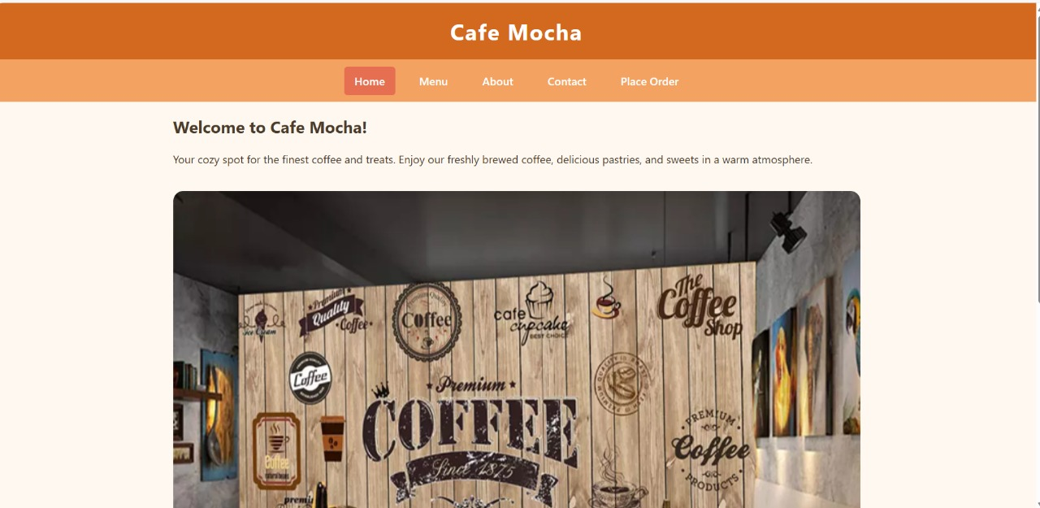

Menu Page
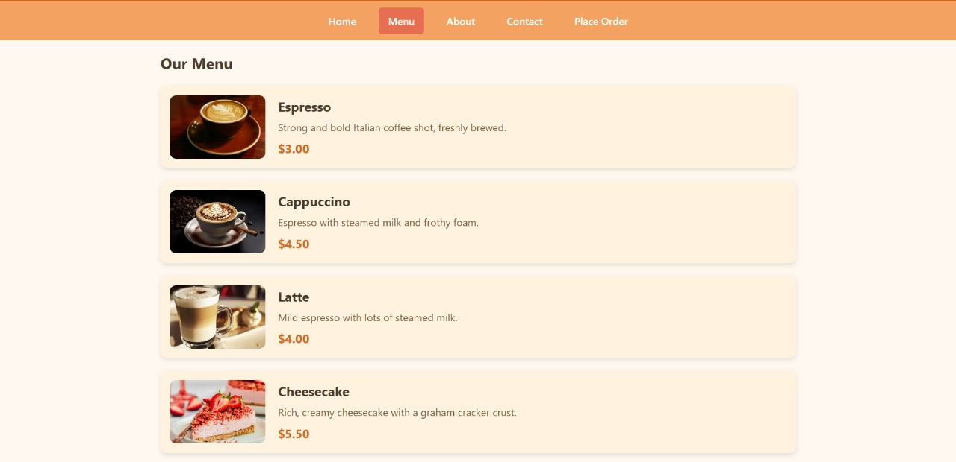

About Page
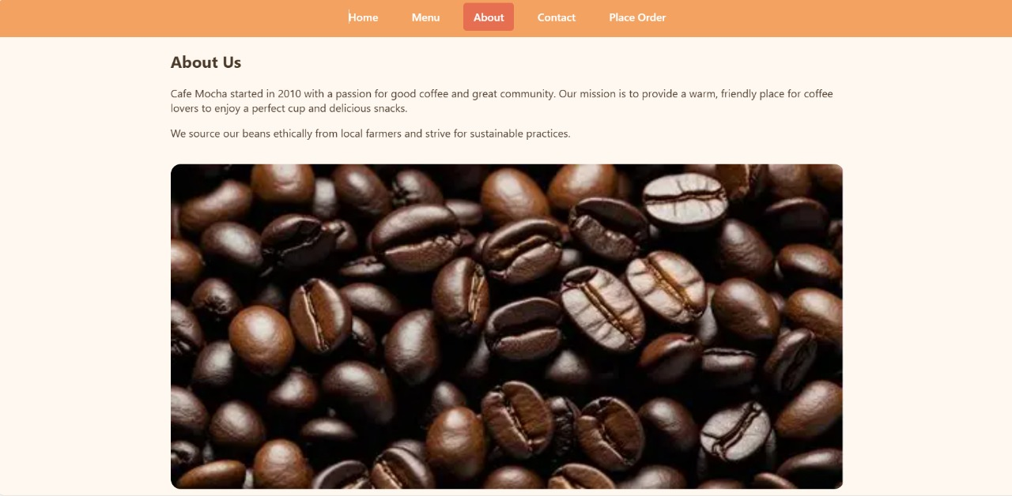

Contact Page


Place Order Page
